MUTUAL FUND ANALYTICS PLATFORM

Project Report

1. INTRODUCTION
The Indian mutual fund industry has experienced tremendous growth over the past decade due to increasing financial awareness, digital investment platforms, and the popularity of Systematic Investment Plans (SIPs). Investors today have access to thousands of mutual fund schemes across multiple categories such as equity, debt, hybrid, index, and sectoral funds.
However, with the large volume of available data, it becomes difficult for investors, analysts, and fund managers to extract meaningful insights manually.
The objective of this project is to build a complete Mutual Fund Analytics Platform that collects, processes, analyzes, and visualizes mutual fund data to generate actionable insights regarding:
- Fund performance
- Industry growth
- Investor behavior
- Risk-return characteristics
- Portfolio diversification
- Geographic participation
- SIP trends
- Category preferences
The project follows a complete Data Engineering and Analytics workflow consisting of:
Data Collection
↓
Data Cleaning
↓
Data Transformation
↓
Data Integration
↓
Analytics
↓
Visualization
↓
Business Insights

The final output is an analytics dashboard that helps investors and stakeholders understand the mutual fund industry more effectively.

2. PROJECT OBJECTIVES
The major objectives of this project are:

Objective 1
Analyze NAV performance of mutual fund schemes.

Objective 2
Study Assets Under Management (AUM) growth across fund houses.

Objective 3
Analyze SIP inflow trends and investor participation.

Objective 4
Understand investor demographics.

Objective 5
Perform risk-return analysis using Alpha, Beta, Sharpe Ratio, and Sortino Ratio.

Objective 6
Study portfolio diversification through sector allocation.

Objective 7
Create visual dashboards for decision-making.

3. DATASETS USED
The project uses ten datasets.

Dataset 1: Fund Master
File:
01_fund_master.csv

Contains master information for all mutual fund schemes.
Columns:
- amfi_code
- fund_house
- scheme_name
- category
- sub_category
- plan
- launch_date
- benchmark
- expense_ratio_pct
- exit_load_pct
- fund_manager
- risk_category
Purpose:
Acts as the central reference table.

Dataset 2: NAV History
File:
02_nav_history.csv

Contains daily NAV values.
Columns:
- amfi_code
- date
- nav
Purpose:
Used for:
- Return calculation
- Trend analysis
- Risk analysis

Dataset 3: AUM Data
File:
03_aum_by_fund_house.csv

Contains fund house assets under management.
Purpose:
Analyze industry growth.

Dataset 4: SIP Inflows
File:
04_monthly_sip_inflows.csv

Contains:
- SIP inflow
- SIP AUM
- Active SIP accounts
Purpose:
Analyze retail participation.

Dataset 5: Category Inflows
File:
05_category_inflows.csv

Contains category-wise investments.
Purpose:
Study category popularity.

Dataset 6: Industry Folio Count
File:
06_industry_folio_count.csv

Purpose:
Track investor participation.

Dataset 7: Scheme Performance
File:
07_scheme_performance.csv

Contains:
- Alpha
- Beta
- Sharpe Ratio
- Sortino Ratio
- Drawdown
Purpose:
Risk-return analysis.

Dataset 8: Investor Transactions
File:
08_investor_transactions.csv

Contains:
- Age
- Gender
- State
- Transaction amount
Purpose:
Investor behavior analysis.

Dataset 9: Portfolio Holdings
File:
09_portfolio_holdings.csv

Contains:
- Sector allocation
- Stock holdings
Purpose:
Portfolio analysis.

Dataset 10: Benchmark Data
File:
10_benchmark_indices.csv

Contains benchmark index values.
Purpose:
Benchmark comparison.

4. SYSTEM ARCHITECTURE
The project follows a five-layer architecture.
RAW DATA
↓
EXTRACT
↓
TRANSFORM
↓
LOAD
↓
ANALYTICS
↓
DASHBOARD

This architecture is similar to real-world fintech analytics systems.

5. ETL PIPELINE
ETL stands for:
Extract
Transform
Load

The ETL pipeline is the backbone of the project.

PHASE 1: EXTRACT
In this stage, raw data is collected.
All CSV files are imported using Pandas.
fund_master = pd.read_csv("01_fund_master.csv")
nav_history = pd.read_csv("02_nav_history.csv")
aum = pd.read_csv("03_aum_by_fund_house.csv")

The extracted data contains:
- Missing values
- Duplicate rows
- Different date formats
- Naming inconsistencies
Therefore, transformation is required.

PHASE 2: TRANSFORM
This is the most important phase.
Raw data is converted into analysis-ready data.

Step 1: Data Cleaning

Missing Value Handling
Missing values were identified and corrected.
Example:
Weekend NAV values.
Solution:
Forward fill.
nav["nav"] = nav["nav"].ffill()

Duplicate Removal
Duplicate records were removed.
df.drop_duplicates()

Date Conversion
df["date"] = pd.to_datetime(df["date"])

Benefits:
- Monthly analysis
- Yearly analysis
- Time-series calculations

Step 2: Data Validation
AMFI codes were validated.
Reason:
Ensure all schemes exist in the master database.
Validation rule:
amfi_code ∈ fund_master

Step 3: Data Integration
Datasets were joined together.
Primary key:
amfi_code

Example:
Fund Master
+
NAV History
+
Scheme Performance

This creates a richer dataset.

Step 4: Feature Engineering
New analytical features were created.

Daily Return
Calculated using NAV.
Formula:
Return_t=\frac{NAV_t-NAV_{t-1}}{NAV_{t-1}}
Purpose:
Measure daily performance.

Rolling Returns
Created:
- 30-day return
- 90-day return
- 1-year return
Purpose:
Reduce noise.

CAGR
Formula:
CAGR=\left(\frac{Ending}{Beginning}\right)^{\frac{1}{n}}-1
Purpose:
Annualized growth.

Alpha
Measures excess return.
Interpretation:
Positive Alpha → Fund outperformed benchmark.
Negative Alpha → Underperformed benchmark.

Beta
Measures market sensitivity.
Interpretation:
Beta > 1
More volatile.
Beta < 1
Less volatile.

Sharpe Ratio
Measures return per unit risk.
Higher Sharpe = Better risk-adjusted return.

Sortino Ratio
Measures downside risk-adjusted return.
Better than Sharpe for downside analysis.

Maximum Drawdown
Measures largest fall from peak.
Used to understand worst-case loss.

PHASE 3: LOAD
After transformation, clean data is loaded.
Logical warehouse structure:

Dimension Tables

dim_fund
Contains:
- Scheme
- Category
- Fund House

dim_date
Contains:
- Date
- Month
- Quarter
- Year

Fact Tables

fact_nav
Contains NAV records.

fact_transactions
Contains investor transactions.

fact_performance
Contains performance metrics.
Benefits:
- Faster queries
- Better dashboard performance

6. EXPLORATORY DATA ANALYSIS (EDA)
EDA was performed to understand trends.

Analysis 1: NAV Trend
Dataset:
02_nav_history.csv
Purpose:
Study long-term performance.
Findings:
- Most funds show upward growth.
- Market corrections visible.
- Recovery phases observed.
Conclusion:
Mutual funds create wealth over long horizons.
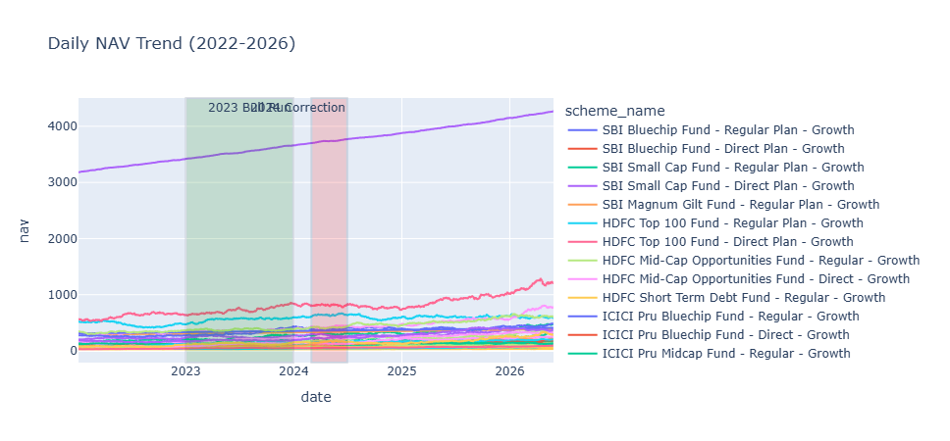

Analysis 2: AUM Growth
Dataset:
03_aum_by_fund_house.csv

Purpose:
Study fund house growth.
Findings:
- SBI MF has highest AUM.
- HDFC and ICICI show strong growth.
- Industry AUM increasing every year.
Conclusion:
Indian mutual fund industry is expanding rapidly.
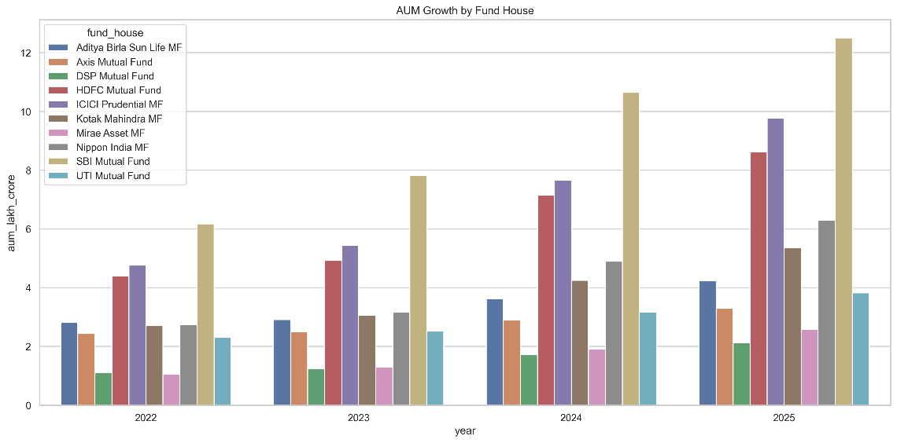

Analysis 3: SIP Inflows
Dataset:
04_monthly_sip_inflows.csv

Findings:
- SIP inflows continuously increasing.
- Peak SIP inflow exceeded ₹31,000 Cr.
Conclusion:
Retail investors prefer disciplined investing.
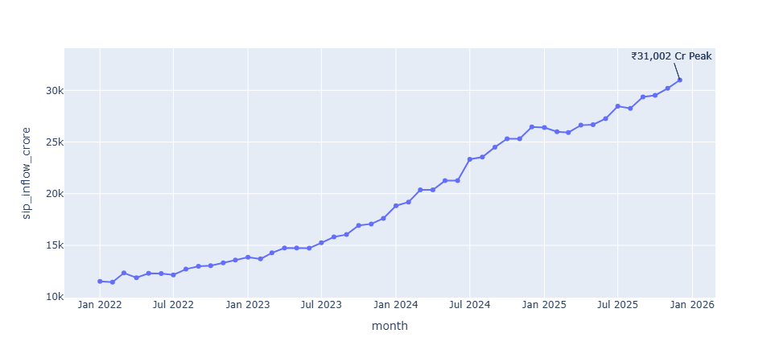

Analysis 4: Category Inflows
Dataset:
05_category_inflows.csv

Findings:
- Liquid Funds dominate.
- Flexi Cap popular.
- Hybrid funds growing.
Conclusion:
Investors prefer diversified products.

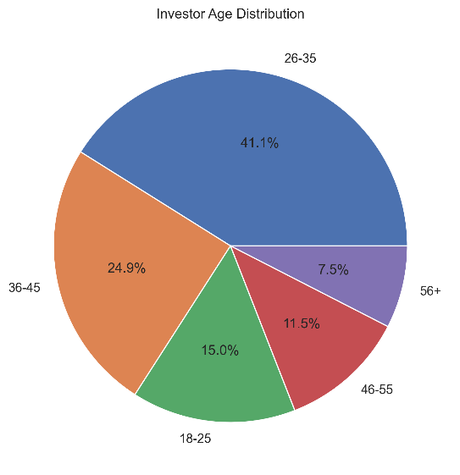
Analysis 5: Investor Age Distribution
Dataset:
08_investor_transactions.csv

Findings:
26–35 age group = largest segment.
Conclusion:
Young professionals drive mutual fund growth.

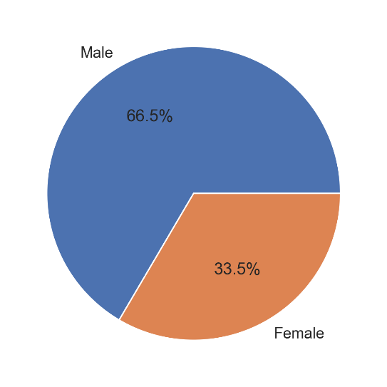
Analysis 6: Gender Analysis
Findings:
- Male ≈ 66%
- Female ≈ 34%
Conclusion:
Female participation increasing but still lower.

Analysis 7: State-wise Analysis
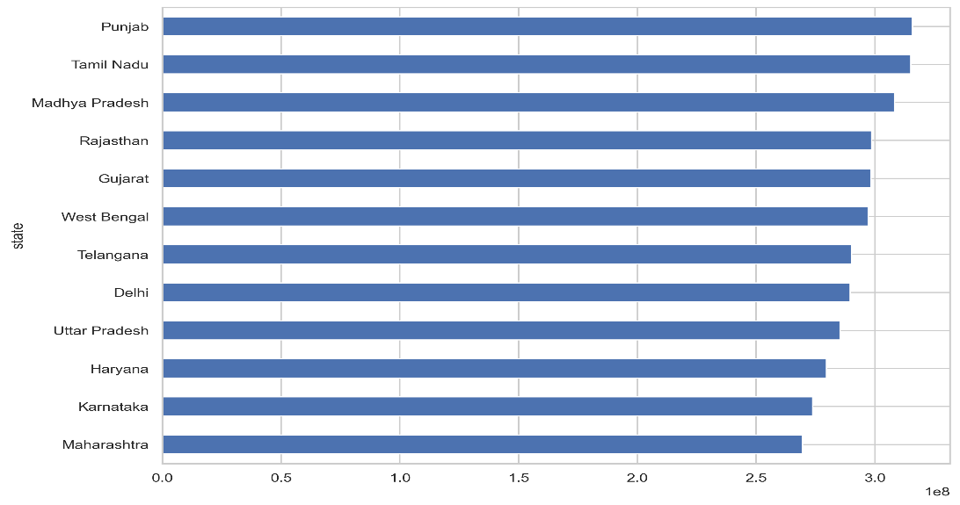
Top contributing states:
- Punjab
- Tamil Nadu
- Madhya Pradesh
- Rajasthan
- Gujarat
Conclusion: Investment participation is geographically diverse.

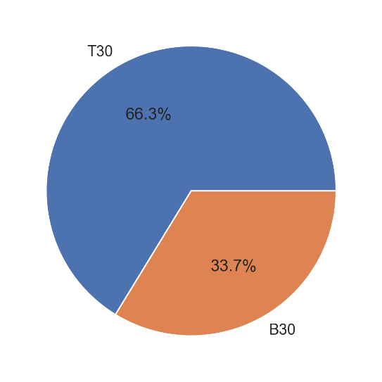
Analysis 8: T30 vs B30
Findings:
- T30 = 66%
- B30 = 34%
Conclusion:
Metro cities dominate investments.

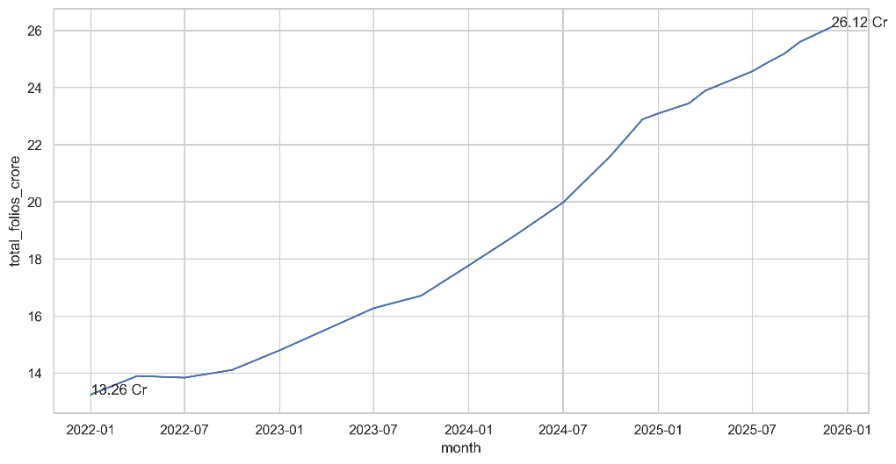
Analysis 9: Folio Growth
Dataset:
06_industry_folio_count.csv

Findings:
Folios increased:
13.26 Cr
↓
26.12 Cr

Conclusion: Investor participation nearly doubled.

7. PERFORMANCE ANALYSIS
Performance analysis evaluates risk and return.

Alpha Analysis
Measures excess return.
Observation:
Many funds have positive alpha.
Meaning:
Fund manager added value.

Beta Analysis
Measures volatility.
Observation:
Some funds are aggressive.
Some are defensive.

Sharpe Ratio Analysis
Higher Sharpe funds provide better risk-adjusted returns.
Used for ranking.

Sortino Ratio Analysis
Focuses only on downside risk.
Useful for conservative investors.

Maximum Drawdown Analysis
Shows worst loss period.
Helps investors assess risk tolerance.

8. CORRELATION ANALYSIS
A correlation matrix was created.
Purpose:
Measure relationships among fund returns.
Findings:
- Most correlations are low.
- Diversification opportunities exist.
Benefit:
Reduces portfolio risk.

9. PORTFOLIO ANALYSIS
Dataset:
09_portfolio_holdings.csv

Sector allocation was analyzed.
Top sectors:
- Banking
- IT
- Pharma
- Automobile
Conclusion:
Most funds maintain diversified portfolios.

10. DASHBOARD DEVELOPMENT
Multiple dashboards were created.
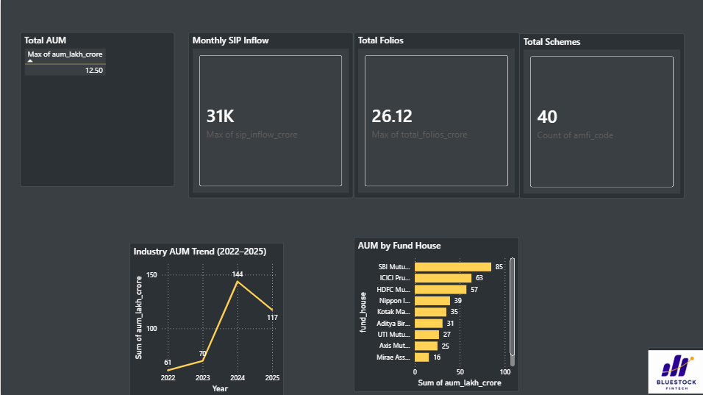
Dashboard 1
Industry Overview
KPIs:
- Total AUM
- SIP Inflow
- Total Folios

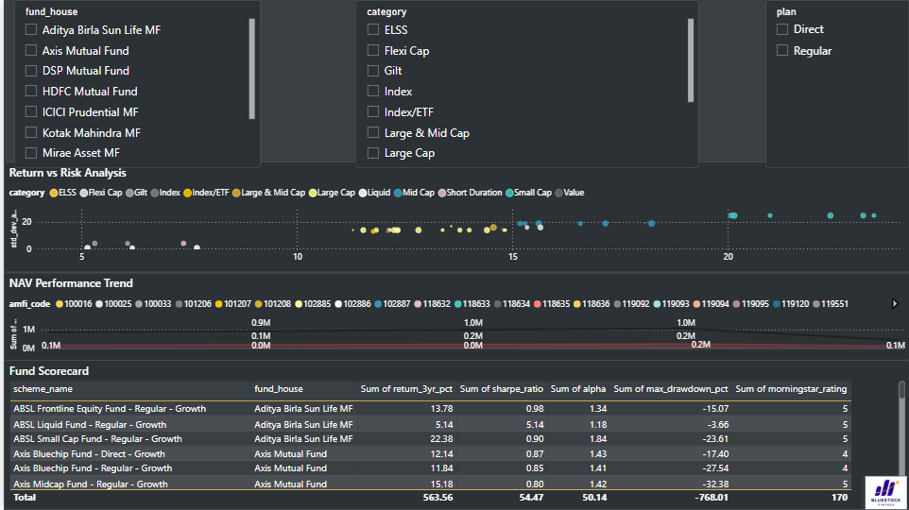
Dashboard 2
Fund Performance
Charts:
- NAV Trend
- Alpha Ranking
- Beta Ranking

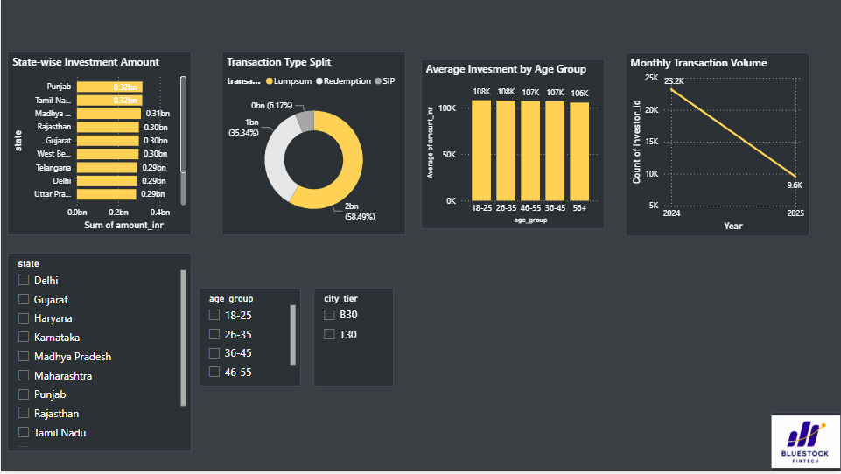
Dashboard 3
Investor Analytics
Charts:
- Age Distribution
- Gender Split
- State Analysis

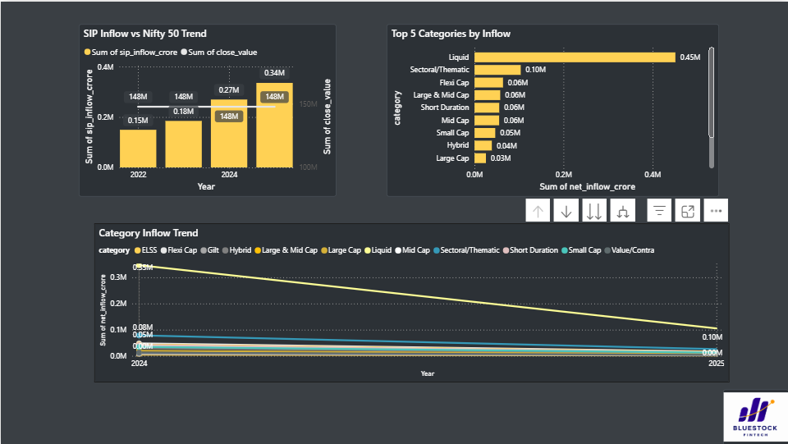
Dashboard 4
Portfolio Analytics
Charts:
- Sector Allocation
- Correlation Matrix

11. KEY INSIGHTS
- Mutual fund industry is growing rapidly.
- SIP investments continue to rise.
- Folio count nearly doubled.
- Young investors dominate participation.
- SBI MF remains industry leader.
- T30 cities contribute majority of assets.
- Liquid and Flexi Cap categories attract strong inflows.
- Diversification opportunities exist due to low correlations.
- Several funds exhibit positive alpha.
- Banking and IT remain dominant sectors.

12. FUTURE ENHANCEMENTS
- Live AMFI API integration.
- Real-time NAV updates.
- AI-based fund recommendation engine.
- Portfolio optimization module.
- Risk forecasting using Machine Learning.
- Automated report generation.
- Predictive AUM forecasting.
- Real-time investor sentiment analysis.

13. CONCLUSION
The Mutual Fund Analytics Platform successfully transformed raw mutual fund datasets into meaningful business intelligence through a structured ETL pipeline, analytical modeling, and interactive visualizations. The project integrated data from fund master records, NAV history, AUM statistics, SIP inflows, investor transactions, portfolio holdings, and benchmark indices to provide a comprehensive view of the mutual fund ecosystem.
Through data cleaning, transformation, feature engineering, and performance analysis, important insights regarding industry growth, investor behavior, fund performance, risk characteristics, and portfolio diversification were obtained. The study revealed strong growth in SIP participation, increasing AUM across major fund houses, rising folio counts, and significant opportunities for diversification.
The project demonstrates how data engineering, analytics, and visualization techniques can be combined to support investment decision-making, risk assessment, portfolio management, and strategic planning in the mutual fund industry. This platform can serve as a foundation for future enhancements such as real-time analytics, machine learning models, and intelligent fund recommendation systems.

